SOUTHS PLAYER INJURY PROCEDURES

- OVERVIEW
The number 1 priority for the club is the safety and welfare of players. The following procedures have been to put in place the necessary framework and procedures to support player safety and welfare.

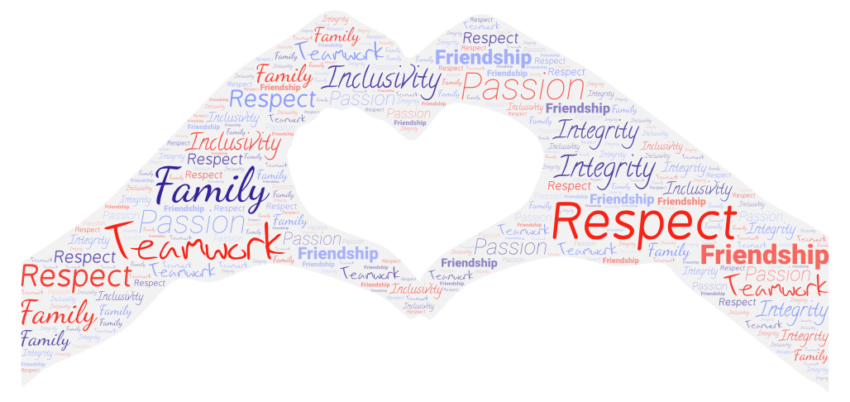
- Procedures

INJURY AT TRAINING:
- Initial Management - basic first aid, call ambulance if necessary. Attempt to contact Jacob/Oscar.
- Souths Injury Report - Online Form
- Contact Family / Next of Kin - arrange mode of transport.
- Contact DOR
- Follow Up Injured Player + Provide Insurance Information (if necessary)
- Player / Injury added to Souths 2024 Injury List (by Jacob / Oscar)
- Player is formally CLEARED prior to return to full training / play (by Club Physio / Doctor)

INJURY AT GAME:
- Initial Management - Physio / Sports Trainer
- Souths Injury Report - Online Form
- Contact Family / Next of Kin (in-person preferred) - arrange mode of transport.
- Contact DOR
- Follow Up Injured Player + Provide Insurance Information (if necessary)
- Player / Injury added to Souths 2024 Injury List (by Jacob / Oscar)
- Player is formally CLEARED prior to return to full training / play (by Club Physio / Doctor)

In the case of a Concussion:
- Document on the team match scorecard any player removed from the field of play with a potential head injury or concussion.
- Enter under injury against the player in Rugby Xplorer as part of post-match tasks.
- Souths Injury Report - Online Form
- Complete Section 1 of Rugby Australia Concussion Referral and Return Form (by Treating person - this may be Match Day Doctor / Physio / Sports Trainer).
- Provide Rugby Australia Concussion Referral and Return Form and Rugby Australia Head Injury Fact Sheet to the player or family member/guardian.
- Remind the player that they must be referred to a medical doctor or emergency department as soon as practical (within 72 hours of the injury)
- Player / Injury added to Souths 2024 Injury List (by Jacob / Oscar)
- Doctor Completes Section 2 of the Rugby Australia Concussion Referral and Return Form (within 72 hours of injury)
- (Player Successfully Completes Graduated Return to Play Program)
- Doctor Completes Section 3 of the Rugby Australia Concussion Referral and Return Form - indicating they have fully recovered from concussion and may return to full contact.
  - 19yrs and Over = 11 days after all Symptoms & Signs have disappeared.
  - 18yrs and Under = 18 days after all Symptoms & Signs have disappeared.
- Player returns Completed Rugby Australia Concussion Referral and Return Form to Club General Manager / Team Manager to approve and record ‘release’ in Rugby Xplorer allowing the player to return to full contact training and play.
**Please see "CONCUSSION" tab in Souths 2024 Injury List for checklist**

NOTES:
- All Registered players will be eligible for up to $3000 to recompense for Rehabilitation Costs and Loss of Income. This excludes any medical costs that are covered by Medicare (e.g. Surgery, Doctors Bills). For Short / Medium term Rehab, this can completely cover the cost of Rehab.
- Rehabilitation and Performance team will meet weekly on Monday to discuss injuries from the Weekend, update Souths 2024 Injury List, create/adjust Rehab Plans and send to relevant coaching staff.
Please click into each of the links to check functionality. If everyone in this email is happy with the above, we will formalise this and send to all managers / staff. It is imperative we are 100% clear with these procedures in 2024.
“ It's Family: For me, Souths is family, and family has the ability to wrap arms around those who need extra support, tell someone to pull their head in if necessary, grow together, with open and honest communication, show tough love if needed, lift each other up during a down moment and joyously celebrate as one. That’s my vision for our players, coaches, managers and community.”
Garrick Morgan, Director of Rugby

