SENIOR GRADES PLAYER RESPONSIBILITIES
Date: Season 2024 – FOR FEEDBACK

- OVERVIEW
As a Souths player you will be representing a club with a long and proud history. The Club:
- Prioritises player welfare above all else.
- Promotes an environment:
  - That values, respect, integrity, and teamwork.
  - That values diversity, family, and community
  - Where you can have pride and in and enjoy your rugby
  - Where you can Build life-long friendships and relationships
  - Where you can develop your rugby skills and progress to your own goals.
It is expected that all players will support and uphold the values of Souths Rugby Union.

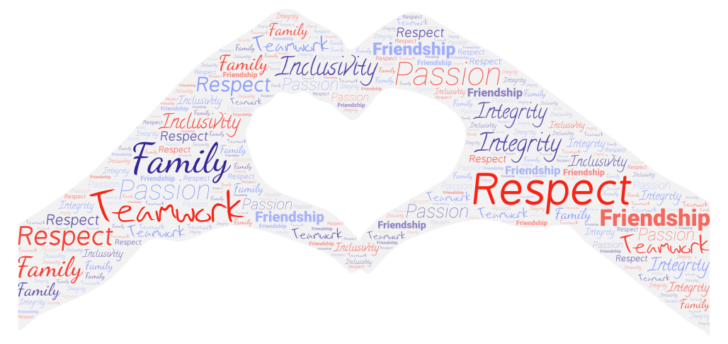

- ACCREDIATION
Required
The following components are mandatory for all players.
Role | Accreditation | Method
Player (Premier Squad) | Rugby Australia Integrity Training | on-line
Player - All | Attend the Souths Rugby Induction Session | Face to face

Recommended
The following on-line programs are available through the Rugby Australia Leaning portal. All players are encouraged to complete the following courses. These courses are also the baseline requirements for many higher-level coaching courses and players are also encouraged to consider personal development for off-field coaching and support roles.
Role | Accreditation | Order | Method | Duration | Cost
Player | Smart Rugby | 1 | on-line | 1 | free
 | Concussion and Serious Injury | 2 | on-line | 1 | free
 | Code of Conduct | 2 | on-line | 1 | free

- RESPONSIBILITIES
  - RELATIONSHIPS
Souths Rugby Union Club is built on Great Relationships:
The role has an inherent responsibility to promote harmony and positivity in interactions with all involved in the Club. Any potential conflict should be addressed quickly using an agreed shared goal. “We both want XXXX, therefore how do we achieve that?
  - GENERAL
- Understand and role model Souths Club Values through promotion of The Souths Way. Support players in understanding and upholding Club Values always.
- Follow club registration processes. All players must be registered for the full season before the pre-season trial games.
- In the event of unavailability on game day you are to notify respective Team Manager, Coach, or teammate.

  - INJURY MANAGEMENT
- Report your injury to medical staff, coach, and team manager.
- Report any unobserved suspected head injury/concussion incidents of teammates to medical staff, coach, team manager.
- Follow the Souths Injury Procedures (INSERT LINK)

  - PRE-GAME \TRAINING
- Attend nominated training sessions, games, or club activities,
- Ensure that you are prepared for and ready to commence training sessions on time.
- All players are to train in appropriate attire, boots, and mouth guards.
- If you are not able to attend training or will be late for training you must notify the respective Team Manager, Coach, or teammate.

  - GAME DAY
- Arrive on game day at the time advised by your Coaches and Managers.
- Support your club mates in other grades.
- To be available as a reserve for higher grades, Colts included.
- All players are to arrive at the ground on match day wearing the Club Polo Shirt.
- All players are to wear the club shorts and socks for matches.
- All players are to play within the Laws of the game of Rugby Union.
- All players are to show respect to Referees and Assistant Referees.
- Perform rostered team club duties ie; BBQ gear storage, raffles, canteen etc
- The captain is the ONLY player to approach on field officials unless requested.
- All players are to show respect to opposition players and officials.
- All players are to play the Club style of Rugby developed by the Coaching Staff.
- All players are to play the “Souths Way” which brings credit and respect to themselves and the Club.
- All players are to show respect to their teammates and have total commitment to the Team.
- Respect Souths and other club’s facilities by ensuring the dressing rooms and playing enclosures are left in a tidy manner.

  - OFF-FIELD BEHAVIOUR
- All players are to conduct themselves in a manner, which only brings credit to themselves and the Club.
- All players are to be courteous and respectful of Club Officials, Sponsors and Supporters.
- All players are to be respectful of Opposition Officials and Supporters.
- All players are to show respect for the Club’s property.
- All players should NOT bring and/or consume alcohol purchased elsewhere.

“ It's Family: For me, Souths is family, and family has the ability to wrap arms around those who need extra support, tell someone to pull their head in if necessary, grow together, with open and honest communication, show tough love if needed, lift each other up during a down moment and joyously celebrate as one. That’s my vision for our players, coaches, managers and community.”
Garrick Morgan, Director of Rugby

