SENIORS COACHES (PREMIER, GRADES, WOMEN AND COLTS)

The role exists to ensure that playing rugby at Souths, as a part of our community is a happy, supportive, rewarding and growth focused experience. We are a performance-oriented inclusive Community Rugby Union Club. Our coaches are the electricity at Souths: they can light players up, dim them or turn them off. This pivotal role enables the players to grow as good human beings, play as a team and reach full individual potential.

The role aligns with, and furthers, ARU, QRU, Club and Rugby strategies whilst upholding and promoting Souths Club member values into our community.

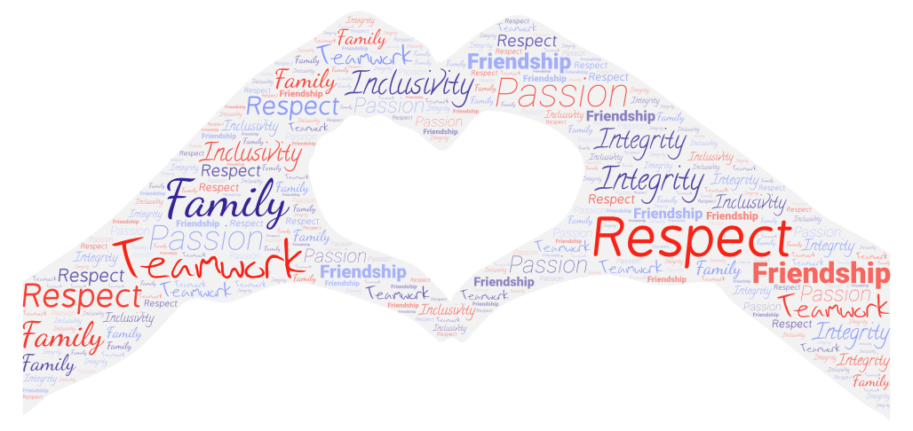

The objectives of our coaches are:

- To understand and align with our Vision, Values and The Souths Way and demonstrate these values and standards in the way they conduct themselves and coach their team.
- To contribute constructively to achieving Rugby Programme goals across the Club including pathways and high performance initiatives.
- To always put player safety and welfare first in particular with concussion management and injury management.
- Contribution to the sustainability of the Club by understanding the importance of teamwork, knowledge transfer, collaboration and mutual support. This includes following Club policies and procedures.
- To maintain and build a team player base by retaining, transitioning and recruiting suitable players.
- To balance high performance with participation and the responsibility to ensure all registered players are included and have an opportunity to play a game.
- To take responsibility for their own education and qualifications (Smart Rugby, Coaching Levels) utilising best practice and resources with World Rugby, the ARU and QRU whilst being supported by the Club wherever possible.
- To promote and protect the Souths Rugby Union brand, reputation and community. And to have the same focus and commitment for our Sponsors and their brands.

Souths Coach Profile – What makes us different? (WIP)

Goal: All Souths Rugby Union Coaches and Players consistently and happily achieve their full potential.

ROLE AND RESPONSIBLITIES

The following duties build relationships and develop Souths rugby union players, teams. And the Club. It includes but is not limited to:

- Organise and attend planning, camps, training and games as per scheduling

- Connect with players, with a finger on the pulse of the playing group, both individually, and as a whole. Identifying opportunities for our community to support individuals if necessary.

- Complete Souths Way Induction including: Club Handbook, ARU Integrity (Code of Conduct, Discipline etc), Child & Youth Safety and policies on Privacy, Social Media, Communication, Reporting and the Souths Rugby Programme.

GENERAL
- Understand and role model Souths Club Values through promotion of The Souths Way. Support players in understanding and upholding Club Values at all times.
- Put player Health and Safety first using a proactive and preventative approach to risk management.
- Structure, plan and run training sessions: off-season, pre-season and season.
- Develop, structure and continually review the team game plan, adapting to available player strengths. Participate in player, team and coaching reviews as required with Director of Rugby.
- Communicate, and check understanding, of the game plan to players.
- Effectively and competitively manage Game Day requirements and players to provide a platform for success.
- Understand and develop each players potential, taking motivations into account. Including utilising Souths Personal Development guidelines.
- Provide constructive and positive feedback and post-game analysis to players using Club guidelines.
- Utilise Club templates where available for example selection criteria.
- Promote the importance of mastery of the basics.
- Recruit and retain players, maintaining a Depth & Readiness chart with Club principles.
- Understand and adhere to player selection guidelines.
- Timely and constructive communication with players on selection decisions and transitions between teams.
- Identify and nurture leadership talent within the team in line with Club expectations.
- Understand and grow individual spirit and team morale in line with Being Great Magpies and The Souths Way.
- Liaise with key stakeholders, especially the team manager, to ensure necessary team support to ensure the smooth running of the team.
- Support the players in matters relating to welfare: using PEMS model (Physical, Emotional, Mental, Spiritual). Seeking Club support where needed.
- Liaise and communicate club news and information especially responsibilities to attend up-coming functions.
- Support the Team Manager in keeping the team informed and engaged with Club activities and events.
- Active and constructive participation in meetings including Coaches Club.
- Ensuring Team Managers have timely and accurate information for game administration including teams, run sheets etc
- Contribute to the Manager’s team report for the Annual Report in a timely manner.
- Promoting Club events and ensuring that all players attend the end of season Presentation Night or sponsor events as required.
- Maintain awareness of competition rules
Souths Ruby Union Club is built on Great Relationships:
The role has an inherent responsibility to promote harmony and positivity in interactions with all involved in the Club. Any potential conflict should be addressed quickly using an agreed shared goal. “We both want XXXX, therefore how do we achieve that?
Essential: Director of Rugby, Players, Managers, S&C, Physios, Competition and Game officials, volunteers,
Secondary: Committee representatives, sponsors, Club Manager and Club members.
“ It's Family: For me, Souths is family, and family has the ability to wrap arms around those who need extra support, tell someone to pull their head in if necessary, grow together, with open and honest communication, show tough love if needed, lift each other up during a down moment and joyously celebrate as one. That’s my vision for our players, coaches and community.”
Garrick Morgan, Director of Rugby

